Monitoring the Atmosphere (Teacher Version)

S2-4-03 Explain effects of heat transfer within the atmosphere and hydrosphere on the development and movement of wind and ocean currents.

Include: Coriolis effect and atmospheric convection, prevailing winds, jet streams, El Nino/La Nina

Check your current understanding:
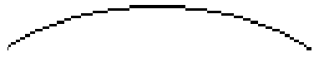
B
D
A
C

Earth Surface

Which letter represents warm air?

Which letter represents cool air?

Which letter represents warming air?

Which letter represents cooling air?

Which letter represents air with high density?

Which letter represents air with low density?

Which letter represents air with increasing density?

Which letter represents air with decreasing density?

What is the source of energy driving this motion?

The “A” arrow alone is known as?

Name the kind of motion represented in the figure above?

On the surface of the Earth, we live at the bottom of an ocean of air. And just like any ocean, the ocean of air has waves rolling along the top. The atmosphere has not “top”, but it still has waves on it nonetheless.

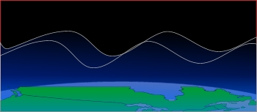

Activity: Build a Classroom Barometer

Materials and Procedure:
- A two litre juice can with the lid cut off makes a good barometer.
- A cut latex balloon, held in place with an elastic band, is used to seal the air in the container.
- The "pointer" is made of two drinking straws taped to the centre of the balloon, and resting on the lip of the juice can as shown.
- Slit one end about 1-2cm and insert the end of one straw inside the other before taping them together.
- Fold a piece of sturdy paper in half and mark it in easily readable increments.
- Place the paper beside the barometer so that the pointer extends over to the paper, but does not touch it.

NOTE: This device is also sensitive to changes in temperature as well as pressure, therefore it is recommenced that one place the barometer in a location where there temperature is likely to remain fairly constant.

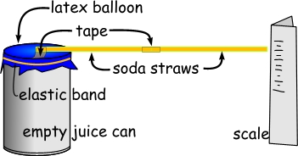
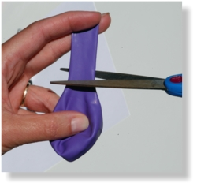
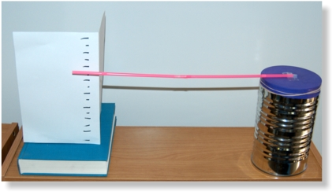

Students will:
1. Plot a daily record of the barometric pressure taking observations daily for at least one month. Record with each reading the current weather conditions.

2. Calibrate the classroom barometer in kilopascals using the barometric pressure from local radio or TV weathercasts.

3. Investigate how "air masses" are related to high and low pressure cells.

4. Monitor the humidity in your classroom. Is there any relationship between the daily weather, the seasonal weather and the humidity of the air in the classroom?

5. Explain any patterns you find.

Barometer Readings and Record

Month: | Classroom Barometer | Local Weather conditions | High pressure | Low Pressure | Humidity
1
2
3
4
5
6
7
8
9
10
11
12
13
14
15
16
17
18
19
20
21
22
23
24
25
26
27
28
29
30
31

Teacher Information:

As the waves pass overhead we can observe their passage as changes in barometric pressure on the Earth's surface.

It is the passage of these waves that is responsible for the changes in weather that we experience each day.

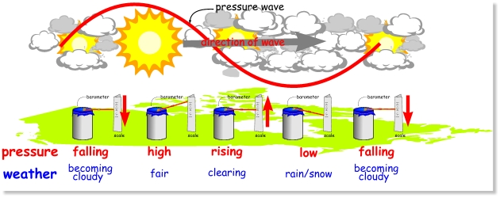

- Under a low pressure the weather is stormy (Winnipeg), under a high pressure the weather is fair (Calgary).

- When the barometer is "falling", (changing), and pressure is becoming lower (ThunderBay) the weather will get worse within the next 12 hours.

- When the barometer is "rising ", that is changing and pressure is becoming higher (Regina) the weather will get much better within the next 12 hours.

- By carefully monitoring changes in a barometer one can make 12h weather forecasts which are about 90% accurate in terms of general weather conditions.

Highs, Lows, Winds and Jet Streams

Teacher Information:
It's often said that we live under an "ocean of air," and like an ocean of water exerting great pressure at its depths, the atmosphere presses upon everything within its boundaries. Air has mass, and due to the gravitational pull of the Earth, it has weight.

Just as a submarine experiences less pressure from the surrounding water as it nears the surface, so air pressure decreases with an increase in elevation or altitude. With less air above, there is less mass being pulled down by gravity, resulting in lower air pressure. Air flows from regions of high pressure to regions of low pressure.

These differing regions are the result of the uneven heating of the Earth's surface and variations in water vapor present. Imagine filling a bath tub with water and attempting to push the water with your hands to one end. The water quickly flows back to its original level, resisting the momentary variation in weight from one end of the tub to the other.

Like water, air always flows toward regions of lower pressure and we experience this flow of air as wind. Its speed and direction are influenced by the Earth's rotation and the surface over which it flows. In the northern hemisphere, air flows into a low pressure center in a counter-clockwise manner. This is caused by the Coriolis Effect and friction, and the resulting low pressure flow of air is called a cyclone. Air flows into the low pressure center and is carried aloft.

In contrast, denser, heavier air sinks in a high pressure center and flows outward in a clockwise manner. This is called an "anticyclone." The greater the difference in neighboring pressure centers, the stronger the flow of air between them. Smaller scale examples of air flow can be caused by the uneven heating of land and water along a coastline resulting in land breezes and sea breezes. Local winds can also be triggered by variations in the heating of different surfaces such as urban concrete and rural vegetation.

Activity: High and Low Pressure

- Ask your students to explain why the wind blows. (Differences in air pressure.)
- From which direction does a north wind blow? (Winds are always named for the direction from which they blow: a north wind is blowing from the north towards the south.)
- What causes the wind to blow from different directions? (Proximity to high and low pressure centers, variations in local surface heating.)
- What effect does a south wind have on local temperature? (For the Northern hemisphere, a south wind generally brings warmer temperatures from the Tropics.)
- A north wind? (Generally brings cooler temperatures nless you live in the Southern Hemisphere: weather and climate are good reminders that the Northern and Southern hemispheres experience nature's forces differently, and that we should constantly remind students that the Coriolis forces, and the rotation of winds around high and low pressure areas, vary depending on which side of the equator you may live.)
- In what direction does air flow in a tornado or hurricane in the northern hemisphere? (Counter-clockwise.)

Distribute and review the student worksheets for this activity.

Canadian Weather at a Glance

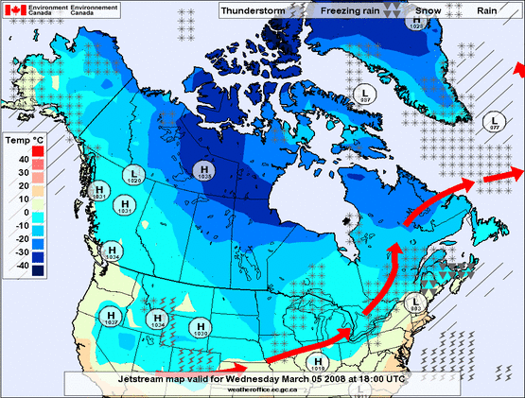
High PressurehPa-hectopascal Low Pressure hPa-hectopascal
Jet Stream
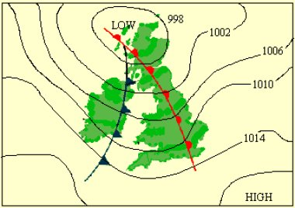
Highs, Lows, Winds and Jet Streams
(Student Worksheet "High")

OBJECTIVE
Students will apply the "hand-twist" model to determine wind direction around high and low pressure centers.
Students will predict changes in surface wind direction caused by movements of high and low air pressure systems.

MATERIALS
- The map of the Canada that is labeled High
- Pencil

PROCEDURE
- Draw a small circle around the large “H” appearing on the map and place the map on a desk top or other smooth table surface.

- Bring the thumb and fingertips of your left hand close together and place them on the circle.

- Slowly rotate your hand (not the map) in a clockwise manner and gradually spread out your thumb and fingers as you lower your palm to the surface. Practice this motion until you can comfortably achieve a full twist.

- Place your thumb and fingertips back in the starting position in the circle. Mark and label the positions of your thumb and fingertips 1, 2, 3, 4 and 5 respectively.

- Slowly rotate your hand clockwise while gradually spreading your thumb and fingers and lowering your palm. Stop, mark and label the new positions 1, 2, 3, 4 and 5 respectively. (If you labeled your thumb 1, continue using 1 for your thumb’s new positions, etc.)

- Follow the same procedure in quarter steps until your palm rests on the surface.

- Connect the numbers for each finger and thumb, successively, resulting in five smooth curved lines. (Connect all the 1’s together, all the 2’s together, etc.) Draw arrows on the lines showing the directions your thumb and fingers moved.

- The spiral you have drawn represents airflow out of a high pressure system.

Proceed to Worksheet Low.
Name ___________________________________ Date __________

Highs, Lows, Winds and Jet Streams
(Student Worksheet "Low")

OBJECTIVE
Students will apply the "hand-twist" model to determine wind direction around high and low pressure centers.
Students will predict changes in surface wind direction caused by movements of high and low air pressure systems.

MATERIALS
- The map of the Canada that is labeled Low
- Pencil

PROCEDURE
- Draw a small circle around the large “L” appearing on the map.
- Place the map on a desk top or table surface. Place your hand flat on the map, fingers spread, with your palm on the circle.
- Slowly rotate your hand (not the map) in a counter-clockwise manner and gradually draw your thumb and fingers together until they touch as you raise your palm. Practice this motion until you can comfortably achieve a full twist.
- Place your hand flat on the map, fingertips spread, in the starting position with your palm on the circle. Mark and label the positions of your thumb and fingertips 1, 2, 3, 4 and 5 respectively.
- Slowly rotate your hand counter-clockwise while gradually drawing your thumb and fingers together and raising your palm. Stop, mark and label the new positions 1,2,3,4 and 5 respectively.
- Follow the same procedure in quarter steps until your thumb and fingers touch together and your palm is at its highest point.
- Connect the numbers for each finger and thumb, successively, resulting in five smooth curved lines. (Connect all the 1’s together, all the 2’s together, etc.) Draw arrows on the lines showing the directions your thumb and fingers moved.
- The spiral you have drawn represents airflow into a low pressure system.
- Describe the flow of surface wind around a high pressure system.
- Describe the flow of surface wind around a low pressure system.
- The motion of your palm represents the vertical direction of air in high and low pressure centers. What is the vertical motion of air in a high? What is the vertical motion of air in a low?
- Examine the Activity Sheets. From which direction is the wind blowing in the city west of the High? From which direction is the wind blowing in the province west of the Low?
- As the high and low pressure centers move eastward across Canada, how will wind directions change for the surrounding cities?
Highs, Lows, Winds and Jet Streams
(Student Worksheet "High")

OBJECTIVE
Students will apply the "hand-twist" model to determine wind direction around high and low pressure centers.
Students will predict changes in surface wind direction caused by movements of high and low air pressure systems.

MATERIALS
- The map of the Canada that is labeled High
- Pencil

PROCEDURE
- Draw a small circle around the large “H” appearing on the map and place the map on a desk top or other smooth table surface.

- Bring the thumb and fingertips of your left hand close together and place them on the circle.

- Slowly rotate your hand (not the map) in a clockwise manner and gradually spread out your thumb and fingers as you lower your palm to the surface. Practice this motion until you can comfortably achieve a full twist.

- Place your thumb and fingertips back in the starting position in the circle. Mark and label the positions of your thumb and fingertips 1, 2, 3, 4 and 5 respectively.

- Slowly rotate your hand clockwise while gradually spreading your thumb and fingers and lowering your palm. Stop, mark and label the new positions 1, 2, 3, 4 and 5 respectively. (If you labeled your thumb 1, continue using 1 for your thumb’s new positions, etc.)

- Follow the same procedure in quarter steps until your palm rests on the surface.

- Connect the numbers for each finger and thumb, successively, resulting in five smooth curved lines. (Connect all the 1’s together, all the 2’s together, etc.) Draw arrows on the lines showing the directions your thumb and fingers moved.

- The spiral you have drawn represents airflow out of a high pressure system.

Proceed to Worksheet Low.
Name ___________________________________ Date __________

Highs, Lows, Winds and Jet Streams
(Student Worksheet "Low")

OBJECTIVE
Students will apply the "hand-twist" model to determine wind direction around high and low pressure centers.
Students will predict changes in surface wind direction caused by movements of high and low air pressure systems.

MATERIALS
- The map of the Canada that is labeled Low
- Pencil

PROCEDURE
- Draw a small circle around the large “L” appearing on the map.
- Place the map on a desk top or table surface. Place your hand flat on the map, fingers spread, with your palm on the circle.
- Slowly rotate your hand (not the map) in a counter-clockwise manner and gradually draw your thumb and fingers together until they touch as you raise your palm. Practice this motion until you can comfortably achieve a full twist.
- Place your hand flat on the map, fingertips spread, in the starting position with your palm on the circle. Mark and label the positions of your thumb and fingertips 1, 2, 3, 4 and 5 respectively.
- Slowly rotate your hand counter-clockwise while gradually drawing your thumb and fingers together and raising your palm. Stop, mark and label the new positions 1,2,3,4 and 5 respectively.
- Follow the same procedure in quarter steps until your thumb and fingers touch together and your palm is at its highest point.
- Connect the numbers for each finger and thumb, successively, resulting in five smooth curved lines. (Connect all the 1’s together, all the 2’s together, etc.) Draw arrows on the lines showing the directions your thumb and fingers moved.
- The spiral you have drawn represents airflow into a low pressure system.
- Describe the flow of surface wind around a high pressure system.
- Describe the flow of surface wind around a low pressure system.
- The motion of your palm represents the vertical direction of air in high and low pressure centers. What is the vertical motion of air in a high? What is the vertical motion of air in a low?
- Examine the Activity Sheets. From which direction is the wind blowing in the city west of the High? From which direction is the wind blowing in the province west of the Low?
- As the high and low pressure centers move eastward across Canada, how will wind directions change for the surrounding cities?

Resources

Synaptic Chart composed of Isobars
http://www.ace.mmu.ac.uk/eae/Figures/isobars.html

Passport to Knowlegde: High,Low, Wind, and Jet Stream Activity
http://passporttoknowledge.com/scic/jetstreams/educators/highslows.html

Classroom Barometer
http://www.science.gc.ca/Lesson_Plans/Lesson_Plans:_Monitoring_the_Atmosphere-WS8E2607CB-1_En.htm

Environment Canada
http://www.on.ec.gc.ca/skywatchers/index_e.html

